**WCHD Wellness 2018 Year in Review**

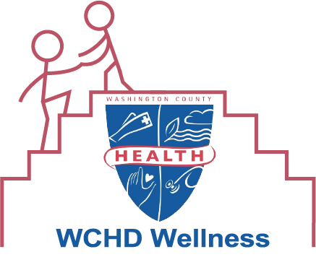

**Overview**

2018 was WCHD Wellness’ first full year of activity. WCHD Wellness implemented 3 challenges, 2 programs, and 3 daily challenges from [kindspring.org](https://www.kindspring.org/). A total of 65 employees participated in these programs. Of the 5 challenges and programs, 56 employees participated and each employee participated in 1.8 programs. The following employees participated in all 5 programs throughout the year: Laura Bennett, Tammi Fuller, Kelly Marquart, Jennifer Smith, and Brittany Young!

Additionally, WCHD Wellness implemented three ongoing programs - Fruit of the Month, Take a Walk Thursdays, and Lunchtime Stretching and Meditation - and a mental health awareness campaign.

The second annual Employee Health Interest Survey was conducted in September-October 2018. The results of the survey are available for any employee to view. WCHD also completed the CDC Worksite Health ScoreCard. The ScoreCard assesses what evidence-based health promotion strategies are currently being implemented at WCHD. The table below shows a summary of WCHD’s 2018 and 2017 scores. The results of the ScoreCard are available for any employee to view.



**Evaluation**

WCHD Wellness met 12 of the 13 evaluation goals set. Please see the WCHD Wellness 2018 Evaluation for details.

**Budget**

Starting in FY19, WCHD Wellness has an annual budget of $1,500. Prior to that, the L1091 ledger account was used. For a list of 2018 expenses, please see the WCHD Wellness 2018 Expenses.

**Fruit of the Month**

On the first Wednesday of each month, employees could try a sample of a different fruit in the kitchens at the main building then also Behavioral Health and WIC. The fruits for each month along with approximately how many employees tried each fruit are listed below.

* January 2018 – Kiwifruit ~17
* February 2018 – Strawberry Papaya 25
* March 2018 – Mango ~39
* April 2018 – Red d’Anjou Pear ~48
* May 2018 – Guava ~53
* June 2018 – Apricot ~24+
* July 2018 – Dragon Fruit ~27+
* August 2018 – Fig ~30
* September 2018 – Star Fruit ~34
* October 2018 – Kumquat ~41
* November 2018 – Prickly Pear ~36
* December 2018 – Passion Fruit ~17

When asked on the Health Interest Survey to describe how Fruit of the Month has influenced their fruit and vegetable consumption, several employees indicated that they are more open to trying new fruits and vegetables and some said that they have discovered a new fruit they like.

**New Year, New You**

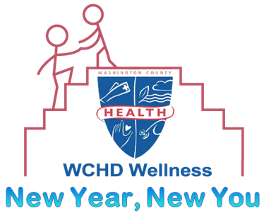

New Year, New You consisted of two separate 10-week challenges that ran from January-March. There was a step challenge and a weight loss challenge. Employees could join both challenges. 21 employees total signed up for the challenge, including 17 in the step challenge and 11 in the weight loss challenge. At the end, a celebration was held where the winners were announced.

Step Challenge

Step tracking logs were posted in the hallways with each participant represented by a character. A weekly step leaderboard was kept. The final leaderboard can be viewed [here](https://docs.google.com/document/d/1aM2Ov7B_5Tn_qDpeeq5v0iUhclAyVW3YmfG_OnXvE5k/edit?usp=sharing). The colored dots on the [map](https://drive.google.com/file/d/1s5mRENFv3QFcB43zWR86RtYxP9ZDLmnN/view?usp=sharing) below show how far participants walked from the health department based on their step counts.

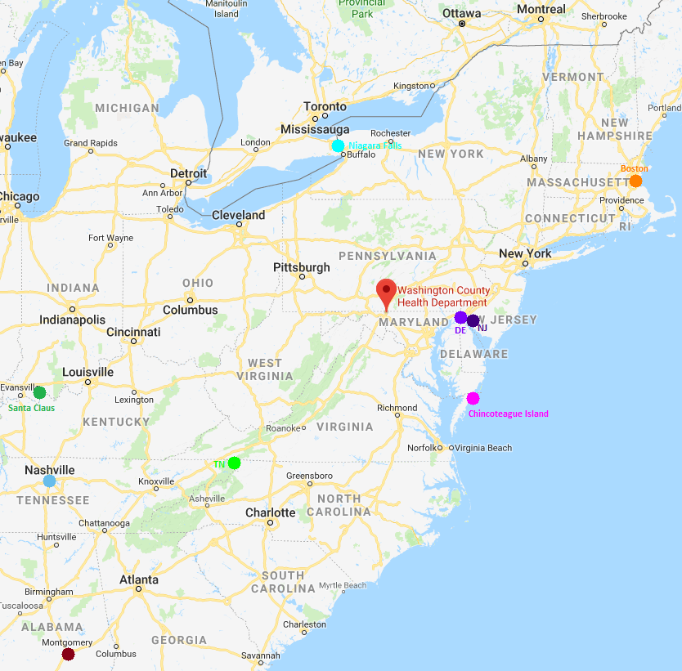

Highest Total Step Counts:

1. Jennifer Smith - 1,419,027 steps
2. Audra Nichols - 1,133,455 steps
3. Lisa McCray - 1,011,994 steps

Most Improved Weekly Step Averages:

1. Audra Nichols - 3,446 more steps
2. Holly Luther - 3,337 more steps
3. Tammi Fuller - 1,848 more steps

**Grand Prize Winners:**

* Most Steps: Jennifer Smith
* Most Improved Weekly Step Average: Audra Nichols

Weight Loss Challenge

Participants in the weight loss challenge weighed-in at the beginning of the challenge and then weighed-out at the end of the challenge. The goal was to lose the greatest percent of your starting weight.

Highest Percent Weight Lost:

1. Tammi Fuller - 11.4% lost
2. Brittany Young - 5.52% lost
3. Mary McPherson - 3.47% lost

**Grand Prize Winner:** Tammi Fuller

Grand Prize Winners Jennifer Smith, Tammi Fuller, and Audra Nichols with Hannah Person

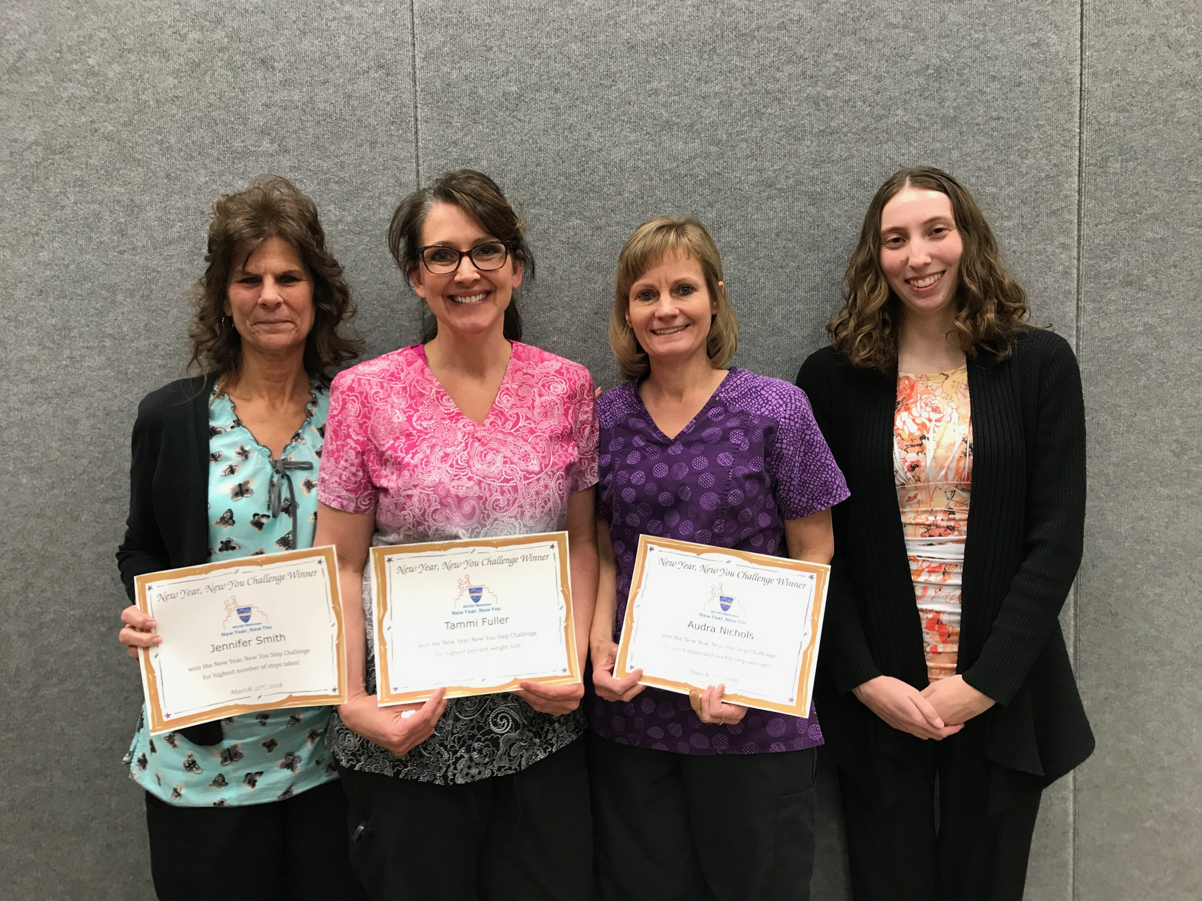

**Kindness Challenge**

The 21-day kindness challenge from kindspring.org in February sent participants an email each day with a kindness activity to engage in that day. 19 employees signed up for this challenge.

**Take a Walk Thursdays**

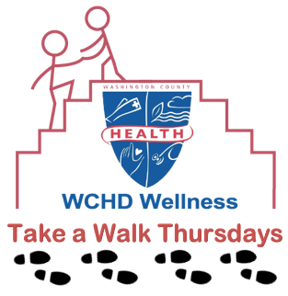

Every Thursday from April-October at 12:30pm, employees could take a walk together during their lunch on the walking path behind Western Maryland Hospital Center. 13 total employees participated in this program and there ranged from 1-6 employees on each walk. Participants expressed enjoying taking a break away from the office. The walking path is open to the public, so employees can walk there any time.

**Finding Balance**

Finding Balance was an 8-week stress management program that had employees keep track of their stress levels and gave tips to help reduce stress. 27 employees signed up for this program. All participants who signed up for this challenge received a small succulent plant. Most participants indicated that their stress decreased between the start and end of the program.

**Mindfulness Challenge**

The 21-day mindfulness challenge from kindspring.org in June sent participants an email each day with a mindfulness activity to engage in that day. 21 employees signed up for this challenge.

**Summer Health Challenge**

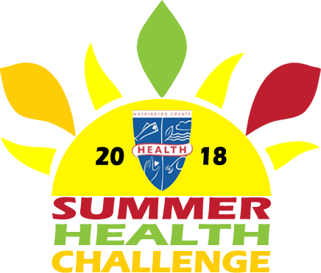

The Summer Health Challenge was an 8-week challenge in July-August that included weekly activities in three categories: physical activity, nutrition, and wellness. Participants earned points by completing the activities each week. There were 24 participants in the challenge. The winners were announced at the annual employee summer picnic in September. Grand prizes were given to one person who earned the maximum number of points overall and one person in each of the three categories who earned the maximum number of points in that category.

Participants Who Earned the Maximum Number of Points Per Category:

* Overall: Carla Freeman, Robin Mangold, Hannah Person
* Activity: Laura Bennett, Carla Freeman, Diana Gaviria, Robert Maffei, Fern Loomis, Robin Mangold, Hannah Person
* Nutrition: Laura Bennett, Carla Freeman, Robin Mangold, Kelly Marquart, Hannah Person, Brittany Young
* Wellness: Carla Freeman, Robin Mangold, Hannah Person, Brittany Young

**Grand Prize Winners:**

* Overall: Robin Mangold
* Activity: Robert Maffei
* Nutrition: Carla Freeman
* Wellness: Brittany Young

**Lunchtime Stretching and Meditation**

Starting in September, every Monday in the auditorium, employees could participate in 5 minutes of stretching and 5 minutes of meditation during lunch at 12:30pm with the meditation beginning at 12:35pm. Employees can participate in either the stretching or meditation sections or both. 10 total employees participated in this program and there ranged from 1-8 employees each week.

**Rest and Revive**

Rest and Revive was a 6-week sleep management program that helped employees track their sleeping habits and gave tips to help participants sleep better. 26 employees signed up for this program.

**Harvest a Healthier Mind**

Harvest a Healthier Mind was a mental health awareness campaign in October. Each week throughout the month, information about common mental illnesses as well as links to online mental health screenings. Flyers with information about depression were posted around the building.

**Gratitude Challenge**

The 21-day gratitude challenge from kindspring.org in November sent participants an email each day with a gratitude activity to engage in that day. 20 employees signed up for this challenge.

**Maintain, Don’t Gain**

Maintain, Don’t Gain was a 6-week weight maintenance challenge. The goal was to maintain your weight within two pounds during the winter holidays. Participants weighed-in before Thanksgiving and weighed-out in January. 20 employees participated in this program. All employees who maintained their weight received a certificate and were eligible for a raffle. At the end, a celebration was held where the raffle was drawn.

The following participants successfully maintained their weight during the challenge: Anne Schooley, Arlene Shuster, Audra Nichols, Carla Freeman, Diana Gaviria, Jennifer Smith, Judi Maliskas, Kelly Marquart, Kimberly Ward, Laura Bannett, Mary McPherson, Melissa Crawford-Halterman, Michelle Hutchinson, Shelby Hughes, Susie Fisher, Tammi Fuller, Tammy Franklin.